Regionalization of Minnesota’s Rivers for Application of River Nutrient Criteria

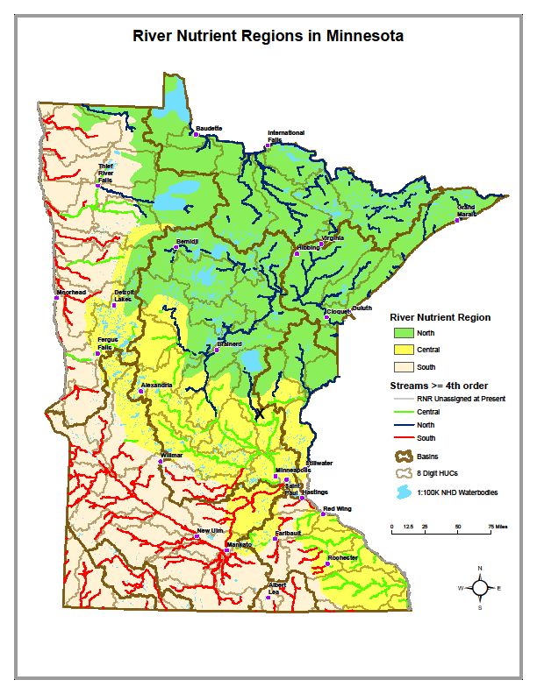

Environmental Analysis and Outcomes



August 2009
Regionalization of Minnesota’s rivers for application of river nutrient criteria

Prepared by: Steve Heiskary and Kristofor Parson Environmental Analysis and Outcomes Division (EAO)

With assistance & review from:
- Kevin Stroom (EAO), John Sandberg (EAO),Will Bouchard (EAO) and Mark Tomasek (EAO) – approach development, map and text review;
- Basin reviews of maps and text: Justin Watkins (Lower Miss.), Molly MacGregor and Bruce Paakh (Red), Larry Gunderson (Minnesota), Chris Klucas (St. Croix), and Maggie Leach (Upper Mississippi)

Date: August 3, 2009

We have long recognized regional patterns in the water quality of Minnesota’s lakes and rivers (e.g., Heiskary and Wilson 1989 and McCollor and Heiskary 1993). USEPA recommends its aggregated level III “Nutrient Ecoregions” as one basis for regionalizing nutrient criteria (http://www.epa.gov/waterscience/criteria/nutrient/ecoregions/ ). In Minnesota’s recently promulgated lake nutrient criteria, USEPA level III ecoregions were grouped as follows to allow for three distinct “regional’ sets of criteria: 1) Northern Lakes and Forests (NLF); 2) North Central Hardwood Forests (CHF), and 3) Western Corn Belt Plains (WCP) and Northern Glaciated Plains (NGP). Lakes in the three “lake-poor” regions – Northern Minnesota Wetlands (NMW), Red River Valley (RRV; also referred to as Lake Agassiz Plain[LAP]), and Driftless Area (DA; also referred to as Paleozoic Plateau) are evaluated on a site specific basis but in most instances the NLF criteria are used to assess NMW lakes and CHF criteria are used to assess RRV and DA lakes.

As with lakes there are some relatively distinct differences in river water quality in Minnesota among the various ecoregions. An early effort by McCollor and Heiskary (1993) examined distributions for various water quality parameters based on typical and minimally-impacted river sites in each ecoregion. An example of that analysis is provided in Table 1a. USEPA (2000) provided distributions for various nutrient ecoregions as a part of guidance on developing river nutrient criteria and an example of that work is provided in Table 1b.

Defining the appropriate ecoregion a lake should be assigned to is a relatively simple task, with the exception of those at or near an ecoregion boundary and/or where the lake or reservoir may have a very large watershed that drains multiple ecoregions (e.g. Lake Pepin). In those instances reach specific decisions are often called for and a weight of evidence approach (e.g. relative percentage contribution by ecoregion) is used to guide the appropriate region and criteria. With rivers this is more complicated as the river may originate in one region but eventually flow through and receive drainage from multiple ecoregions. The Mississippi River is a good example as it originates in the NLF and weaves its way through central Minnesota where drainage from CHF (e.g. Sauk, Rum, and Elk Rivers) and even WCP ecoregions (e.g. South Fork Crow) enter before it reaches the Twin Cities Metro area and merges with the St. Croix and Minnesota Rivers.
In view of the patterns in Table 1 and monitoring and data analysis conducted to-date in development of river nutrient criteria (Heiskary and Markus 2001, Heiskary and Markus 2003, and Heiskary et al. in prep.) criteria are needed for three river nutrient regions (RNR): North, Central and South. These regions generally correspond to the USEPA aggregated Level III Nutrient ecoregions (Figure 1a) with aggregations as follows:
- North – NLF and NMW ecoregions;
- Central – CHF and DA ecoregions and
- South – WCP, NGP and LAP ecoregions.

With this as a starting point and recognizing that rivers traverse various regions and landscapes from their origin to their confluence with another river, some means was needed to specifically identify which rivers (assessment reaches) correspond to which RNR for the purpose of applying the river nutrient criteria. To help frame this, river-watersheds at the eight digit HUC level (81 watersheds) were selected as a primary basis to develop this framework (Figure 1b). These 81 watersheds, as derived from MDNR’s major watershed (DNR Catchments) layer, are also a focus of MPCA’s “pour-point” monitoring program (http://www.pca.state.mn.us/water/monitoring/monitoring-watersheds.html )and several of these rivers were included in our river nutrient studies (Figure 1a). In terms of watershed size the 8 digit HUCs (Table 2) and 4th order and higher streams (Table 3) are most similar to the rivers that were used in our river nutrient research and as such are likely to be an appropriate scale for assessment and application of the criteria. Based on a comparison of Tables 2 and 3 the 8 digit HUCs are most similar to 5th order streams, while 11 digit HUCs are most similar to 3rd order streams.

When an 8 digit HUC is located completely within a RNR or where a vast majority of the watershed is within a single RNR the assignment to that RNR is rather straightforward, (e.g. Otter Tail, North Fork and South Fork of the Crow River; Figure 2). However, when an 8 digit HUC traverses multiple ecoregions the appropriate designation may be less apparent (e.g. Wild Rice, Buffalo and Red Lake Rivers; Figure 2). In these cases closer inspection was required and 11 digit HUCs (Watershed 99 HUC 11 layer) were incorporated into the mapping coverage to allow for refinement of boundaries. The process for defining the appropriate RNR for each is summarized as follows:
- MDNR’s coverage for the 81 major watersheds (8 digit HUC) was overlain on a level III ecoregion map (Figure 1b). The areal ecoregion composition (% and total area) of each watershed was determined using GIS. These maps and statistical summaries serve as an initial basis for sorting rivers (watersheds) into the three RNRs.
- 11 digit HUC layer was added to allow for more detailed examination and determining appropriate breakpoints within an 8 digit HUC.
- 4th order and higher stream reaches were noted in bold, while 3rd order or less were noted by a finer line to show general flow patterns and linkages among the HUCs. The stream traces were later color coded by RNR.
- The 81 watersheds were then sorted by 8 digit HUC within each basin. HUCs corresponding to the main-stem of the Mississippi, Minnesota, Red and St. Croix Rivers were sorted separately (Table 4c) to allow for individual assessment and assignment to a RNR.
- Ecoregion composition and maps were reviewed at the 8 digit HUC level to define the ecoregion(s) that accounted for the majority of the watershed. When an eight-digit HUC was completely within a single ecoregion (e.g. Cloquet River, Table 4a) it was assigned to the corresponding RNR (North in this case). Also when the vast majority of an eight-digit HUC was characterized by one or more ecoregions within a common RNR and the remaining portion represented a very small area the predominant RNR was assigned, e.g. Long Prairie with 88% in CHF ecoregion and 12% in NLF (105 mi²) was assigned to the Central RNR (Table 4a).
- Eight-digit HUCs characterized by multiple ecoregions were sorted out separately (Table 4b). For these, a closer evaluation at the 11 digit HUC level was conducted to discern the appropriate RNR for that 11 digit HUC and/or portion thereof. This evaluation considered the relative percentage ecoregion contribution within and upstream of that 11 digit HUC and water quality data from the river nutrient study (e.g. Heiskary et al. 2009 in prep.) or as summarized from MPCA Environmental Data Access (e.g. Figure 3). Where possible, specific locations near cities, major highways and/or river confluences were used to help define the transition from one RNR to the next. 4th order and larger tributaries were color coded and in bold, while 3rd order or lower were represented with finer lines.

The North RNR is comprised by the NLF and NMW ecoregions and includes 20 watersheds (un-aggregated 8 digit HUCs) plus two main-stem reaches on the Mississippi. The NLF ecoregion accounts for the highest percentage by area (Table 4a). The North RNR watersheds range from 277 mi² (Beartrap) to 2,859 mi² (St. Louis).

The Central RNR is characterized by a wide mix of ecoregions and no single ecoregion was dominant across all the rivers included in this region (Table 4). This is a function of the “transitional” nature (change from forest-dominated to agricultural-dominated landscape) and that many of the rivers drain from adjacent ecoregions (e.g. NLF or WCP) into the central RNR. Only 11 eight-digit HUCs were fully included in this RNR – sentence unclear. These watersheds are smaller than those of the northern RNR and range from 93 mi² (LaCresent) to 1,909 mi² (Otter Tail).The Central and South RNRs include pooled reaches on the Mississippi River, which were called out separately for reach specific nutrient criteria development (Heiskary 2009 in prep.)

The majority of the 26 watersheds in the South RNR are in the Minnesota River Basin where the WCP and NGP ecoregions are dominant. Watersheds of the South RNR range from 41 mi² (Big Sioux) to 2,082 mi² (Hawk-Yellow Medicine). In two of the Minnesota River Basin watersheds: Pomme de Terre and Chippewa the CHF ecoregion comprises a significant portion of the upper watershed and these 8 digit HUCs were included with those characterized by multiple ecoregions (Table 4b). Several 8 digit HUCs in the Red River Basin that are characterized primarily by the LAP ecoregion were included in the south RNR as well.

The above described approach is applied to a majority of the 8 digit HUCs in Minnesota and RNR assignments were made (Table 4). Figure 4 is a statewide representation of the RNR boundaries and assignments as of this writing. This map demonstrates the general boundaries of the three RNRs and the assignments of major (4th order and higher) rivers that drain the respective 8 digit HUCs and basins. In addition to this statewide map, working maps were developed at the 8 digit and 11 digit HUC level as needed to discern transitions from one RNR to the next for rivers that drain multiple RNRs. All major rivers have been coded in this process with the exceptions as follows where further reach specific analysis is being conducted:

1. Red River main-stem: The Red River main-stem will be addressed separately because of: a) previous analysis of nutrient and chlorophyll-a relationships indicates it does not fit the statewide model (e.g. Heiskary and Markus 2003), b) it receives drainage from an array of ecoregions (Table 3), and c) it has an appreciable portion of its watershed in North Dakota, and d) downstream receiving waters in Canada have acknowledged problems with excess nutrients. All of these factors suggest a need for development of nutrient criteria specific to the Red River main-stem. That process will be conducted in conjunction with the Red River Basin team and will likely demand collaboration with North Dakota and possibly Canada.

2. Mississippi River navigation pools: Pools 1-8 that range from St. Anthony Falls in the northern Metro area to Pool 8 near the Iowa border will have reach specific nutrient criteria developed. Reach specific criteria are desired for the following reasons: nutrient and chlorophyll-a relationships may be quite different from more free-flowing rivers (because of increased residence time, deeper mixed layer, and related factors) and these pooled reaches are of a higher order than most of the rivers used in development of the river nutrient criteria (typically 4th-7th order). A proposed approach and draft criteria, in collaboration with Wisconsin DNR and Minnesota DNR, have been developed and are in review (Heiskary 2009 in prep.).
Figure 1. Location of: a) 1999, 2000, 2006 and 2008 study sites overlain on USEPA aggregated level 3 “nutrient” ecoregions and b) location of 86 major watershed “pour points.”

a) river nutrient study sites
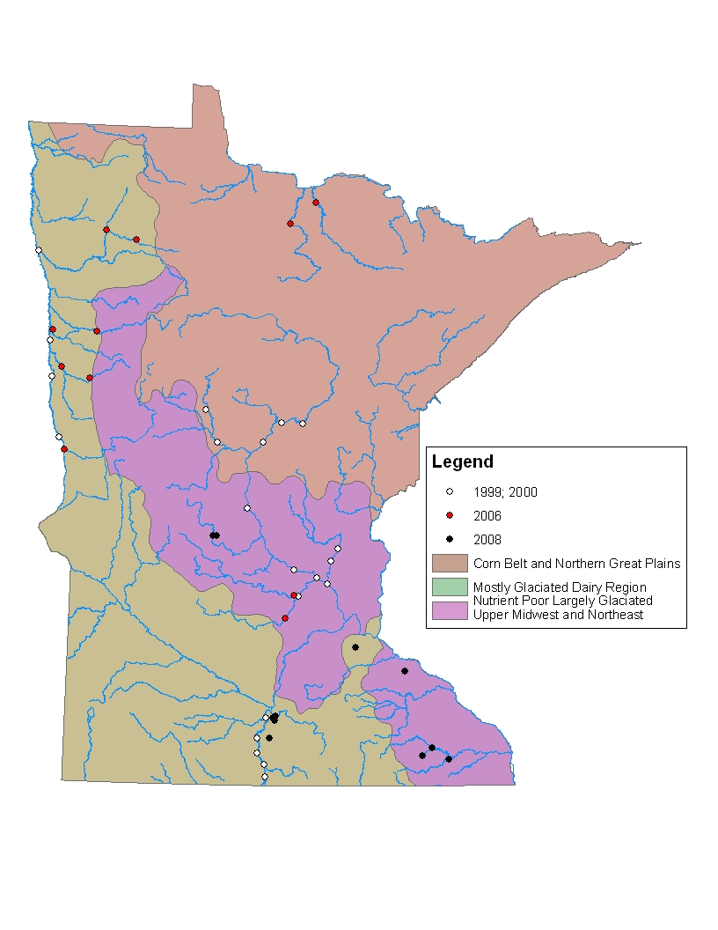
b) 86 pour-points
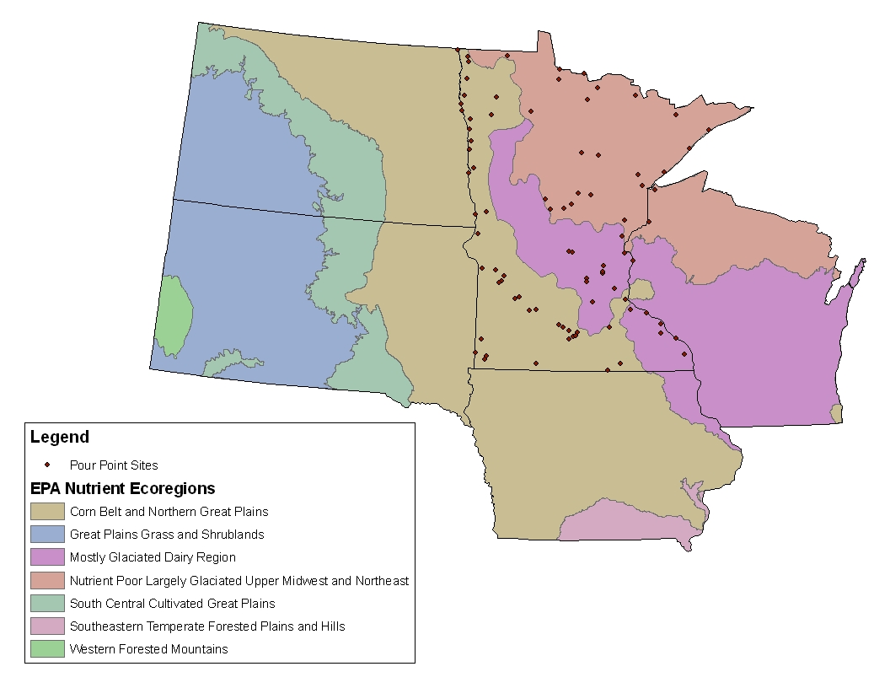
Figure 2. Major watershed “pour points” and level 3 ecoregion composition for Red and Upper Mississippi River Basins. Percent ecoregion composition noted for select “pour points” and corresponding RNR for each. Rivers marked with * require assessment at a finer level of resolution (11 digit HUC).

RNR | -------N----------| ----C----|-------S----------|

River  (pour point) | %  NLF | %  NMW | %  CHF | % LAP | % WCP | RNRReg.
Miss. (Brainerd) | 99% |  |  |  |  | N
Pine | 100% |  |  |  |  | N
Rum (mouth) | 26% |  | 74% |  |  | *
Sauk |  |  | 100% |  |  | C
Crow (N. Fork) |  |  | 94% |  | 6% | C
Crow (S. Fork) |  |  | 24% |  | 76% | S
Miss. (Anoka) | 52% |  | 42% |  | 6% | C
Red River
Red Lake | 10% | 44% | 5% | 41% |  | *
Wild Rice | 21% |  | 15% | 64% |  | *
Buffalo | 2% |  | 32% | 66% |  | *
Otter Tail | 16% |  | 78% | 6% |  | C

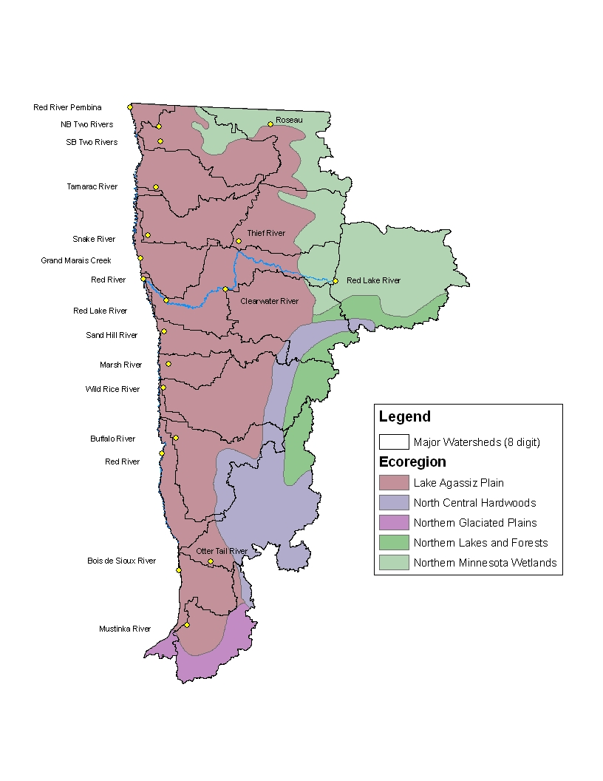

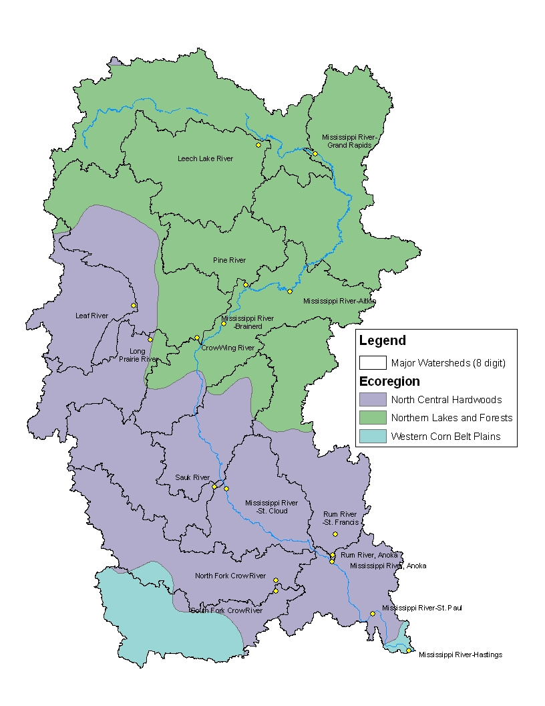

Figure 3. River total phosphorus data as derived from STORET. Based on 64,514 TP measurements from 1,994 stations. Values represent mean for each station based on data collected between Jan. 1, 1995-March 24, 2009. Shaded regions approximate the three RNRs as grouped by ecoregions. Map provided by John Sandberg.

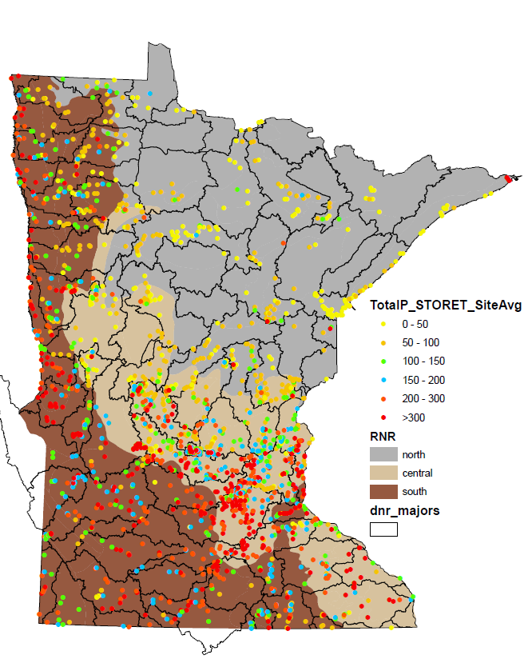
Statewide TP distribution based on summarized data from 1,994 stations in STORET.

Percentile TP µg/L
5th | 31
10th | 40
25th |  | 68
30th | 79
40th | 104
50th | 140
60th | 179
70th | 228
75th | 260
90th | 431
95th | 621

Statewide TP distribution based on summarized data from 1,994 stations in STORET.

Percentile TP µg/L
5th | 31
10th | 40
25th |  | 68
30th | 79
40th | 104
50th | 140
60th | 179
70th | 228
75th | 260
90th | 431
95th | 621

Figure 4. River Nutrient Regions (RNR). Classification developed at the 8 digit and 11 digit HUC level as needed. 4th order and larger rivers coded with their respective RNR.

Table 1a. Interquartile range (25th – 75th percentiles) of summer-mean concentrations for minimally impacted streams in Minnesota, by Level III ecoregion. Data from 1970-1992. TP = total phosphorus, TSS = total suspended solids. (McCollor and Heiskary 1993)

Eco-region | TP (µg/l) |  |  | Turbidity (NTU) |  |  | TSS (mg/l) |  |  | BOD (mg/L)
 | 25% | 50% | 75% | 25% | 50% | 75% | 25% | 50% | 75% | 25% | 50% | 75%
NLF | 30 | 40 | 50 | 2 | 2 | 4 | 2 | 4 | 6 | 0.9 | 1.2 | 1.6
NMW | 50 | 60 | 90 | 5 | 7 | 12 | 7 | 11 | 20 | 1.2 | 1.5 | 1.9
CHF | 70 | 100 | 170 | 5 | 7 | 10 | 8 | 10 | 18 | 1.6 | 2.2 | 3.3
NGP | 160 | 220 | 290 | 20 | 23 | 37 | 37 | 55 | 89 | 2.6 | 3.8 | 5.6
RRV | 140 | 220 | 330 | 13 | 19 | 28 | 28 | 50 | 74 | 2.0 | 2.8 | 4.5
WCP | 210 | 270 | 350 | 14 | 19 | 27 | 26 | 47 | 76 | 2.2 | 4.3 | 6.6

Table 1b. Interquartile range of summer-mean concentrations. Derived from USEPA (2000) nutrient criteria guidance documents (level III ecoregion # noted in parenthesis)

Region | TP (µg/l) |  |  | Turbidity (NTU)
 | 25% | 50% | 75% | 25% | 50% | 75%
NLF (50) | 15 | 30 | 60
NMW (49) | 50 | 60 | 80
CHF (51) | 40 | 95 | 200 | 2.6 | 3.9 | 5.8
NGP (46) | 210 | 314 | 448 | - | - | -
RRV (48) | 170 | 230 | 285
WCP (47) | 130 | 240 | 359 | 15.0 | 40.0 | 55.0

Table 2. Watershed area as a function Hydrologic Unit Code: comparison of 8 digit and 11 digit. 8 digit statistics are for un-aggregated 8 digits HUCs exclusive of main-stem HUCs for the Red, Mississippi, Minnesota and St. Croix Rivers. Watershed area for river nutrient (RN) data set offered for comparison.

Area (mi²)
HUC | N | Mean | 25th | 50th | 75th | min | max
8 digit | 70 | 1,036 | 600 | 1,016 | 1,405 | 14 | 2,589
11 digit | 931 | 91 | 29 | 69 | 126 | <1 | 882
RN | 43 | 3,816 | 563 | 1,435 | 3,600 | 45 | 25,450

Table 3. Watershed area as a function of stream order.
Analysis based on ~1,560 biological monitoring stream sites

Area (mi²)
Order | 10th | 25th | 50th | 75th | 90th
2nd | 5 | 8 | 14 | 28 | 44
3rd | 15 | 26 | 49 | 85 | 176
4th | 56 | 104 | 162 | 278 | 521
5th | 411 | 662 | 1,002 | 1,508 | 3,487
6th | 1,186 | 3,432 | 6,238 | 7,443 | 14,490

Table 4. Ecoregion classification of Minnesota rivers at 8 digit HUC level. Sorted by River Nutrient Region (RNR) [N=North (NLF & NMW), C=Central (CHF & DA), S=South (LAP, WCP, & NGP)] and 8 digit HUC. Total area of unaggregated 8 digit HUC and % composition by ecoregion: NLF=Northern Lakes and Forests, NMW=northern Minnesota Wetlands, CHF=North Central Hardwoods Forests, DA=Driftless Area, LAP=Lake Aggasiz Plain, NGP=Northern Glaciated Plains, and WCP=Western Corn Belt Plains.

Table 4a. 8 digit HUCs characterized by a single or vast majority in a RNR

 | North
RNR |  |  | N | N | C | C | C | S | C
HUC 8 | Name | Area Mi² | %  NLF | % NMW | % CHF | % DA | % LAP | % NGP | % WCP | RNR
04010101 | Baptism-Brule | 1,581 | 100 | 0 | 0 | 0 | 0 | 0 | 0 | N
04010102 | Beaver-Lester | 624 | 100 | 0 | 0 | 0 | 0 | 0 | 0 | N
04010201 | St. Louis | 2,859 | 100 | 0 | 0 | 0 | 0 | 0 | 0 | N
04010202 | Cloquet | 793 | 100 | 0 | 0 | 0 | 0 | 0 | 0 | N
04010301 | Beartrap-Nemadji | 277 | 100 | 0 | 0 | 0 | 0 | 0 | 0 | N
07010103 | Prairie-Willow | 2,082 | 100 | 0 | 0 | 0 | 0 | 0 | 0 | N
07010104 | Elk-Nokasippi | 1,686 | 81 | 0 | 19 | 0 | 0 | 0 | 0 | N
07010105 | Pine | 780 | 100 | 0 | 0 | 0 | 0 | 0 | 0 | N
07030001 | Upper St. Croix | 547 | 100 | 0 | 0 | 0 | 0 | 0 | 0 | N
07030003 | Kettle | 1,051 | 97 | 0 | 3 | 0 | 0 | 0 | 0 | N
09020302 | Red Lakes | 1,940 | 18 | 80 | 2 | 0 | 0 | 0 | 0 | N
09020314 | Roseau | 1,055 | 0 | 72 | 0 | 0 | 28 | 0 | 0 | N
09030001 | Rainy Headwaters | 2,499 | 100 | 0 | 0 | 0 | 0 | 0 | 0 | N
09030002 | Vermilion | 1,033 | 100 | 0 | 0 | 0 | 0 | 0 | 0 | N
09030003 | Rainy Lake | 904 | 82 | 18 | 0 | 0 | 0 | 0 | 0 | N
09030004 | Upper Rainy | 506 | 0 | 100 | 0 | 0 | 0 | 0 | 0 | N
09030005 | Little Fork | 1,872 | 36 | 64 | 0 | 0 | 0 | 0 | 0 | N
09030006 | Big Fork | 2,055 | 39 | 61 | 0 | 0 | 0 | 0 | 0 | N
09030007 | Rapid | 944 | 0 | 100 | 0 | 0 | 0 | 0 | 0 | N
09030008 | Lower Rainy | 305 | 0 | 100 | 0 | 0 | 0 | 0 | 0 | N
09030009 | Lake of the Woods | 1,142 | 0 | 100 | 0 | 0 | 0 | 0 | 0 | N
 | Count | 21
 | Central
07010107 | Redeye | 894 | 2 | 0 | 98 | 0 | 0 | 0 | 0 | C
07010108 | Long Prairie | 883 | 12 | 0 | 88 | 0 | 0 | 0 | 0 | C
07010201 | Platte-Spunk | 1,026 | 20 | 0 | 80 | 0 | 0 | 0 | 0 | C
07010202 | Sauk | 1,042 | 0 | 0 | 100 | 0 | 0 | 0 | 0 | C
07010203 | Clearwater-Elk | 1,121 | 0 | 0 | 100 | 0 | 0 | 0 | 0 | C
07010204 | North Fork Crow | 1,476 | 0 | 0 | 94 | 0 | 0 | 0 | 6 | C
07040003 | Buffalo-Whitewater | 651 | 0 | 0 | 0 | 100 | 0 | 0 | 0 | C
07040006 | La Crosse-Pine | 93 | 0 | 0 | 0 | 100 | 0 | 0 | 0 | C
07040008 | Root | 1,659 | 0 | 0 | 0 | 89 | 0 | 0 | 11 | C
07060001 | Coon-Yellow | 184 | 0 | 0 | 0 | 100 | 0 | 0 | 0 | C
09020103 | Otter Tail | 1,909 | 16 | 0 | 74 | 0 | 10 | 0 | 0 | C
 | Count | 11
HUC 8 | Name | Area Mi² | % NLF | % NMW | % CHF | % DA | % LAP | % NGP | % WCP | RNR
 | South
07010205 | South Fork Crow | 1,278 | 0 | 0 | 25 | 0 | 0 | 0 | 75 | S
07020004 | Hawk-Yellow Medicine | 2,082 | 0 | 0 | 2 | 0 | 0 | 15 | 83 | S
07020006 | Redwood | 699 | 0 | 0 | 0 | 0 | 0 | 46 | 54 | S
07020008 | Cottonwood | 1,314 | 0 | 0 | 0 | 0 | 0 | 14 | 86 | S
07020009 | Blue Earth | 1,220 | 0 | 0 | 0 | 0 | 0 | 0 | 100 | S
07020010 | Watonwan | 873 | 0 | 0 | 0 | 0 | 0 | 0 | 100 | S
07020011 | Le Sueur | 1,111 | 0 | 0 | 8 | 0 | 0 | 0 | 92 | S
07060002 | Upper Iowa | 224 | 0 | 0 | 0 | 47 | 0 | 0 | 53 | S
07080102 | Upper Wapsipinicon | 14 | 0 | 0 | 0 | 0 | 0 | 0 | 100 | S
07080201 | Upper Cedar | 713 | 0 | 0 | 0 | 0 | 0 | 0 | 100 | S
07080202 | Shell Rock | 248 | 0 | 0 | 0 | 0 | 0 | 0 | 100 | S
07080203 | Winnebago | 73 | 0 | 0 | 0 | 0 | 0 | 0 | 100 | S
07100001 | Des Moines Headwaters | 1,248 | 0 | 0 | 0 | 0 | 0 | 15 | 85 | S
07100002 | Upper Des Moines | 89 | 0 | 0 | 0 | 0 | 0 | 0 | 100 | S
07100003 | East Fork Des Moines | 204 | 0 | 0 | 0 | 0 | 0 | 0 | 100 | S
09020101 | Bois De Sioux | 554 | 0 | 0 | 0 | 0 | 86 | 14 | 0 | S
09020102 | Mustinka | 861 | 0 | 0 | 7 | 0 | 43 | 50 | 0 | S
09020107 | Elm-Marsh | 362 | 0 | 0 | 0 | 0 | 100 | 0 | 0 | S
09020301 | Sandhill-Wilson | 619 | 0 | 0 | 5 | 0 | 95 | 0 | 0 | S
09020306 | Grand Marais-Red | 592 | 0 | 0 | 0 | 0 | 100 | 0 | 0 | S
09020309 | Snake | 779 | 0 | 0 | 0 | 0 | 100 | 0 | 0 | S
09020312 | Two Rivers | 1,100 | 0 | 19 | 0 | 0 | 81 | 0 | 0 | S
10170202 | Upper Big Sioux | 41 | 0 | 0 | 0 | 0 | 0 | 100 | 0 | S
10170203 | Lower Big Sioux | 510 | 0 | 0 | 0 | 0 | 0 | 40 | 60 | S
10170204 | Rock | 914 | 0 | 0 | 0 | 0 | 0 | 5 | 95 | S
10230003 | Little Sioux | 326 | 0 | 0 | 0 | 0 | 0 | 0 | 100 | S
 | Count | 26
Table 4b | Multiple regions
07010106 | Crow Wing | 1,981 | 59 | 0 | 41 | 0 | 0 | 0 | 0
07010207 | Rum | 1,583 | 43 | 0 | 57 | 0 | 0 | 0 | 0
07020002 | Pomme De Terre | 875 | 0 | 0 | 38 | 0 | 0 | 61 | 0
07020005 | Chippewa | 2,078 | 0 | 0 | 55 | 0 | 0 | 14 | 31
07030004 | Snake | 1,006 | 50 | 0 | 50 | 0 | 0 | 0 | 0
07030005 | Lower St. Croix | 915 | 2 | 0 | 92 | 0 | 0 | 0 | 6
07040001 | Rush-Vermillion | 594 | 0 | 0 | 13 | 46 | 0 | 0 | 41
07040002 | Cannon | 1,470 | 0 | 0 | 33 | 18 | 0 | 0 | 49
07040004 | Zumbro | 1,421 | 0 | 0 | 0 | 70 | 0 | 0 | 30
09020106 | Buffalo | 1,131 | 1 | 0 | 28 | 0 | 70 | 0 | 0
09020108 | Eastern Wild Rice | 1,636 | 20 | 0 | 15 | 0 | 65 | 0 | 0
09020303 | Red Lake River | 1,340 | 0 | 21 | 0 | 0 | 79 | 0 | 0
09020304 | Thief | 1,048 | 0 | 37 | 0 | 0 | 63 | 0 | 0
09020305 | Clearwater | 1,359 | 15 | 7 | 17 | 0 | 61 | 0 | 0
 | count | 14
Table 4c | Main stems¹
07010101 | Mississippi Headwaters | 1,920 | 100 | 0 | 0 | 0 | 0 | 0 | 0 | N
07010102 | Leech Lake | 1,341 | 100 | 0 | 0 | 0 | 0 | 0 | 0 | N
07010206 | Twin Cities | 1,007 | 0 | 0 | 95 | 0 | 0 | 0 | 5 | C
07020001 | Upper Minnesota | 786 | 0 | 0 | 0 | 0 | 0 | 83 | 17 | S
07020003 | Lac Qui Parle | 760 | 0 | 0 | 0 | 0 | 0 | 31 | 69 | S
07020007 | Middle Minnesota | 1,347 | 0 | 0 | 9 | 0 | 0 | 0 | 91 | S
07020012 | Lower Minnesota | 1,835 | 0 | 0 | 66 | 0 | 0 | 0 | 34 | S
09020104 | Upper Red | 500 | 0 | 0 | 5 | 0 | 95 | 0 | 0
09020311 | Lower Red | 883 | 0 | 0 | 0 | 0 | 100 | 0 | 0
 | count | 9
1. Red River and Mississippi River pools to be addressed separately in site specific efforts

Rivers comprised of multiple ecoregions and RNR assignments

% composition by ecoregion
HUC8 name mi² NLF NMW CHF DA LAP NGP WCP
07010106 | Crow Wing | 1,981 | 59 | 0 | 41 | 0 | 0 | 0 | 0
Headwaters drain from the NLF ecoregion and an area with numerous lakes. Two major watersheds Red Eye and Long Prairie Rivers drain from CHF ecoregion. As the river flows eastward near Motley it again receives drainage from the NLF ecoregion. Based on river nutrient monitoring in 1999 and 2000 the Crow Wing maintained relatively low TP and Chl-a at CWR-72 (Nimrod) and CWR-35 (Staples).

The 11 digit HUCs that comprise much of the upper watershed: Shell, Straight, Two Inlets, Fish Hook, Mantrap Lake and Upper Crow Wing Rivers are assigned to the North RNR. When the data are considered in conjunction with the ecoregion composition this argues for keeping the entire Crow Wing main-stem in the North RNR. Some of the small 11 digit HUCs (3rd order or lower streams) that are primarily characterized by the CHF ecoregion: Blueberry River, Kettle Creek, Cat River, Swan Creek and Farnham Creek are assigned to the Central RNR. Upper Gull Lake, Gull Lake and Lower Crow Wing Rivers are assigned to the North RNR.

07010207 | Rum | 1,583 | 43 | 0 | 57 | 0 | 0 | 0 | 0
The Rum has its headwaters in Mille Lacs Lake in the NLF ecoregion. The 11 digit HUCs: Bradbury Brook, Tibbets Brook and Upper Rum River to the confluence with the West Branch of the Rum near Princeton are assigned to the North RNR. The West Branch of the Rum, Rum main-stem below the confluence with the Upper Rum and all 11 digit HUCs to the south and east are assigned to the central RNR.

07020002 | Pomme De Terre | 875 | 0 | 0 | 38 | 0 | 0 | 61 | 0
The Pomme de Terre headwaters are in the CHF ecoregion. The 11 digit HUCs that comprise the “headwaters” area are the Upper Pomme de Terre and Pelican Creek (drained by 3rd order or lower streams) and both are assigned to the Central RNR. The transition to the NGP ecoregion occurs near Barrett and USGS gage (05293365). Since no major tributaries enter near this point the outlet of Barrett Lake can serve as a basis for transitioning from the Central RNR to the South RNR. All 11 digit HUCs to the south of this point and the main-stem of the Pomme de Terre are assigned to the South RNR.

07020005 | Chippewa | 2,078 | 0 | 0 | 55 | 0 | 0 | 14 | 31
The Chippewa headwaters are in a lake rich portion of the CHF ecoregion in Pope and Douglas Counties. Lake Emily is located on the CHF – NGP transition and has been assessed for 303(d) as a NGP lake. The transition in lake morphometry and land form is quite distinct as one moves from Lake Minnewaska in central Pope to Emily in the southern Pope County. The portion of the Chippewa north and northeast of Lake Emily and city of Cyrus is assigned to the Central RNR. This would include the following 11 digit HUCs: Upper West Branch, Middle West Branch, Little Chippewa, Trappers Run, East Branch, North Mud Creek, and Upper Shakopee Creek, which are drained by 3rd order or lower streams. The Lower West Branch below Lake Emily and south of Cyrus and all 11 digit HUCs to the south, e.g. Chippewa River, Moore Township Branch Chippewa, Shakopee Creek, etc. to the outlet at the Minnesota River are assigned to the South RNR.

07030004 | Snake | 1,006 | 50 | 0 | 50 | 0 | 0 | 0 | 0
The Snake River headwaters are in the NLF ecoregion just east of Mille Lacs. The 11 digit HUCs that are east of Mille Lacs and north of Knife Lake including the Upper Snake, Lower Upper Snake, Knife River above Knife Lake, the upper Ann River to the outlet of Ann Lake, and the Groundhouse River north of Ogilvie are assigned to the North RNR. The upper portion of the Middle Snake down to the confluence with the outlet of Fish Lake/Ann River south of Mora is assigned to the North RNR and below that point is assigned to Central RNR. The 11 digit HUCs to the south and east including south fork Groundhouse, Middle Snake (east of Knife Lake), Mud Creek, Pokegama Creek, Mission Creek and Lower Snake to the outlet at the St. Croix are assigned to the Central RNR. With the exception of the Snake mainstem, most streams are 3rd order or lower.

07030005 | Lower St. Croix | 915 | 2 | 0 | 92 | 0 | 0 | 0 | 6
The Upper St. Croix flows into this 8 digit HUC. The main-stem of the St. Croix down to Stillwater at the head end of Lake St. Croix is assigned to the North RNR. The remainder of the St. Croix is comprised of Lake St. Croix and that is addressed as a CHF ecoregion lake. All 11 digit HUCs in this 8 digit HUC are assigned to the Central RNR and are drained by 3rd order or lower streams.

07040001 | Rush-Vermillion | 594 | 0 | 0 | 13 | 46 | 0 | 0 | 41
The Vermillion River is a small watershed on the southern edge of the Twin Cities Metro area. The majority of the watershed is in the WCP ecoregion that transitions to the DA ecoregion as it enters the Mississippi River. The Vermillion is assigned to the South RNR and any tributaries located in this HUC that flow from the DA ecoregion to the Mississippi River are assigned to the Central RNR; however most of these are quite small (3rd order or less) and generally <50 mi².

07040002 | Cannon | 1,470 | 0 | 0 | 33 | 18 | 0 | 0 | 49
The Cannon River watershed has two very distinct subwatersheds: the Upper Cannon in the CHF ecoregion and the Straight River in the WCP ecoregion. Lake Byllesby on the Lower Cannon serves to reset the system. RNR assignments are as follows:
1. Watershed of Upper Cannon River (~295 mi²) drains from the CHF. The Upper Cannon River and tributaries that flow directly from the CHF ecoregion to the Cannon main-stem are assigned to Central RNR;
2. Straight River drains from WCP and is assigned to South RNR (~435 mi² at Faribault USGS gage 05353800);
3. The Middle Cannon, which lies below the confluence of the Upper Cannon and Straight (near Faribault) and includes Lake Byllesby, is assigned to the South RNR. Prairie Creek, which flows parallel to the Cannon, is in the WCP and is assigned to the South RNR as well. The main-stem of Chub Creek, which drains from the north, is in the WCP and is assigned to the south RNR as well.
4. Lake Byllesby resets the Cannon River. The Cannon River below Lake Byllesby receives much of its direct drainage from the DA (264 mi²). This reach of the Cannon to the mouth and tributaries (e.g. Belle Creek and Little Cannon) from the DA are assigned to Central RNR.

07040004 | Zumbro | 1,421 | 0 | 0 | 0 | 70 | 0 | 0 | 30

The Zumbro River has three relatively distinct “forks” and one, the Middle Fork, is comprised of three branches. The headwaters of the various forks/branches originate in the WCP ecoregion, while the higher order portions (and 70% of the watershed) are in the DA ecoregion. While the overall contribution from the WCP ecoregion is 30% -- its relative influence (% contribution) may vary among the four branches. Lake Zumbro is a prominent reservoir on the South Fork immediately downstream of the confluence with the Middle Fork and was assessed for 303(d) as a WCP lake. A majority of the WCP portion of Zumbro’s watershed is within Lake Zumbro’s watershed. The five branches/forks and main-stem are assigned as follows:
1. North Fork – The upper portion of the North Fork (e.g. upstream from Kenyon) is assigned to the South RNR. The main-stem of the North Fork east of Kenyon to the confluence with Zumbro main-stem and Trout Brook portion is assigned to Central RNR.
2. North Branch of the Middle Fork – The upper reach of this 11 digit HUC is quite small, drains from the WCP and is assigned to the South RNR. The lower reach from the confluence with the Middle Fork to the WCP transition drains from the DA and is assigned to the Central RNR.
3. Middle Fork – The WCP comprises much of this 11 digit HUC and this branch to the confluence with the North Branch is assigned to the South RNR. The Middle Fork downstream from the confluence with the North Branch receives significant drainage from the DA and is assigned to the Central RNR.
4. South Branch of the Middle Fork – The WCP comprises much this branch and the entire branch from Dodge Center Creek to confluence of North Branch of Middle Fork is assigned to the South RNR.
5. South Fork – The two unnamed branches of the South Fork drain from the WCP and are assigned to the South RNR. At the confluence of the two branches, southwest of Rochester, the relative % of watershed from the DA increases and this 4th order stream merges with a 4th order that drains the SE portion of the South Zumbro. From this confluence (immediately SE of Rochester to Lake Zumbro the DA is the dominant ecoregion and this reach is assigned to the Central RNR.
6. Outlet of Lake Zumbro to the confluence with North Fork and continuing to the outlet of the Zumbro is all within the DA ecoregion and is assigned to the Central RNR.

09020106 | Buffalo | 1,131 | 1 | 0 | 28 | 0 | 70 | 0 | 0

The headwaters of the Buffalo River are in the CHF ecoregion; however a vast majority of the watershed is in the LAP. Since the portion in the CHF is very small (~300 mi²) and there are no major tributaries (4th order or more) draining this portion of the watershed and the entire main-stem is assigned to the South RNR. Stream reaches within the following 11 digit HUCs are assigned to the Central RNR: Upper Buffalo, Lake Park, Olaf-Grove Lakes and eastern portions of Hawley-South Buffalo and Deerhorn-Buffalo. The remaining 11 digit HUCs, through-which the main branches of the Buffalo River flow, are assigned to the South RNR: Middle Buffalo, Lower Buffalo, and western portions of the Hawley-South and Deerhorn-Buffalo. The ecoregion boundaries as drawn represent the transition from the Central to the South RNR in each case.
09020108 | Eastern Wild Rice | 1,636 | 20 | 0 | 15 | 0 | 65 | 0 | 0

The headwaters of the Wild Rice are in the NLF and CHF ecoregions; however the majority of the watershed (65%) is in the LAP ecoregion. The 11 digit HUCs, east of Mahnomen, including: Rice Lake, Upper Wild Rice, Twin Lakes Creek, and White Earth River south of Mahnomen; and Wauban Creek south of Mahnomen are assigned to the Central RNR. Based on river nutrient monitoring in 2006 the Wild Rice remains relatively low in TP at Twin Valley, which suggests that the waters from the upstream HUC’s in the CHF and NLF ecoregions extend their influence at least this far down the main-stem. Based on this the main-stem of the Upper Wild Rice to the confluence with the South Branch Wild Rice is assigned to the Central RNR. Individual 11 digit HUCs that are fully within the LAP ecoregion and tributary to this reach: Marsh Creek, Moshaug, Flom Creek, Coon Creek and Lower Wild Rice are assigned to the South RNR. All tributaries (11 digit HUCs) that drain to and including the South Branch Wild Rice: south Branch Wild Rice, Felton Ditch, and Hendrum, downstream of confluence with Upper Wild Rice are assigned to the South RNR.

09020303 | Red Lake River | 1,340 | 0 | 21 | 0 | 0 | 79 | 0 | 0
The immediate upstream 8 digit HUC is comprised of Upper and Lower Red Lakes and their direct watershed (09020302). Based on 2006 river nutrient monitoring and long-term data TP remains low in the Red Lake River (consistent with North RNR) below the confluence with the Thief River at Thief River Falls, which suggests the portion from Thief River Falls and upstream to Upper and Lower Red Lake can be assigned to the North RNR. This would include the main-stem of the Red Lake River and Upper Red Lake. The tributaries within the 11 digit HUCs: High Landing, Kratka and CD #120 is a transition between regions and is assigned to the Central RNR. The reach of the Red Lake River from Thief River Falls to Red Lake Falls is assigned to the Central RNR because of the increasing portion of the watershed that drains the LAP ecoregion. The next major downstream confluence is with the Clearwater River, which drains portions of four different ecoregions and is assigned to the Central RNR over much of its watershed. The main-stem at Red Lake Falls is assigned to the Central RNR. All of the 11 digit HUCs from Red Lake Falls to the outlet at East Grand Forks lie fully within the LAP (e.g. Burnham, Crookston, and Lower Red Lake River) and are assigned to the South RNR. Monitoring data suggest the main-stem from Red Lake Falls to just above Fischer can be assigned to the Central RNR. The lower reach of the Red Lake River, from the confluence with Burnham Creek to the mouth at East Grand Forks, is assigned to the South RNR. Water quality data at Fischer (S000-031) indicate much higher TP and TSS as compared to upstream sites at Red Lake Falls.

09020304 | Thief | 1,048 | 0 | 37 | 0 | 0 | 63 | 0 | 0

The Thief River drains portions of the NMW and LAP ecoregions. The entire watershed has extensive drainage networks and wetlands appear to be a dominant feature throughout the watershed. While the majority of the watershed is in the LAP the dominance of water and wetlands throughout the entire watershed could allow this 8 digit HUC to be assigned to the North RNR. Monitoring data from a site 6 miles north of Thief River Falls (S004-495) indicates low to moderate TP, which suggests the influence of the NMW portion of the watershed is extended downstream. The 11 digit HUCS in the NMW portion of the watershed: Moose, Mud and Lost Rivers are assigned to the North RNR. The remaining 11 digit HUCS: Goodridge, CD 120, Branch 200, and Thief River are all or mostly in the LAP ecoregion. Given the “blending” of waters from both ecoregions, the prominence of Thief Lake, and the TP concentrations at the downstream end of this 8 digit HUC these 11 digit HUCs are assigned to the Central RNR.

09020305 | Clearwater | 1,359 | 15 | 7 | 17 | 0 | 61 | 0 | 0

The Clearwater River drains portions of four ecoregions with the LAP being dominant in the western portion of the watershed. The upper portion of the Clearwater drains through four of the ecoregions and has a watershed area of about 550 mi². The 11 digit HUCs in the upper portion: Upper Clearwater and Clearwater Rivers drain primarily NLF and NMW ecoregions and are assigned to the North RNR. The next downstream 11 digit HUC is the Plummer, which is in the LAP ecoregion: however low TP from the upstream HUCs moderate the influence of the potentially more nutrient rich runoff within this HUC. Monitoring data collected at Plummer (S002-124) indicate moderate TP concentrations for this reach of the Clearwater and the Plummer HUC is assigned to the Central RNR. The Lost River is the other large tributary in this 8 digit HUC and drains portions of NLF, CHF and LAP ecoregions. Likewise the Poplar and Hill Rivers drain from the CHF to the LAP ecoregions. All three 11 digit HUCs are assigned to the Central

References

Heiskary, S. 2009 (in prep.). Mississippi River Pools 1 through 8: Developing Assessment Reach Specific Nutrient Criteria and Proposed Draft Criteria.

Heiskary, S. 2008. Relation of nutrient concentrations and biological responses in Minnesota streams: applications for river nutrient criteria development. A report based on work conducted as a part of USEPA nutrient criteria grant. MPCA St. Paul MN

Heiskary, S. and H. Markus. 2001. Establishing relationships among nutrient concentrations, phytoplankton abundance, and biochemical oxygen demand in Minnesota USA, rivers. Lake and Reserv. Manage. 17(4):251-262.

Heiskary, S. and H. Markus. 2003. Establishing relationships among in-steam nutrient concentrations, phytoplankton and periphyton abundance and composition, fish and macroinvertebrate indices and biochemical oxygen demand in Minnesota USA, rivers. MPCA St. Paul MN 100 p.

Heiskary, S. and B. Wilson. 2008. Minnesota’s approach to lake nutrient criteria development. Lake and Reserv. Manage. 24:282-297.

Heiskary, S., R.W. Bouchard and H. Markus. in prep. Minnesota nutrient criteria development for rivers. MPCA. St. Paul MN

McCollor, S. and S. Heiskary. 1993. Selected water quality characteristics of minimally impacted streams from Minnesota’s seven ecoregions. Addendum to: Descriptive characteristics of the seven ecoregions of Minnesota. MPCA St. Paul MN

USEPA. 2000. Nutrient criteria technical guidance manual. Rivers and Streams. Office of Water, Washington DC EPA-822-B001-002

